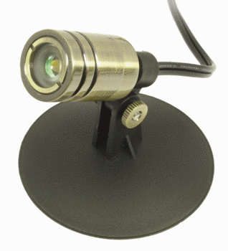LED Pond Lights
Low wattage LED pond lights use only 10% of the power needed for older halogen landscape and pond lights. The color of the light is identical to white halogen bulbs. Available in 1 watt, 3 watt, 6 watt spotlights and other styles

